Smart Campus Placement System

In propose work we are designing and online smart campus placement application which consists of 3 different users describing below

1. Company: company can sign up and login to system, company allowed to post jobs along with job description, salary and skills details, company can questions to database which will be shown to students to write and to get score for selection. Company can view list of selected students along with selected or rejection status.
2. TPO: training placement officer can sign up and login to system and then view feedbacks from all students who are facing challenges in exam and then can approach them to resolve their exam issue
3. Student Modules: student can sign up and login to system and then update profile with academic, skills and resume details
4. Job Recommendation: here we are employing KNN machine learning algorithm to find nearest jobs based on job required skills and student skills and then display all predicted jobs as recommendation. Student can apply desired job and then list of questions will be displayed to answer and to get performance score.
5. Job Status: students can view job status as selected or rejected based on exam performance.
6. Feedback: can raise feedback on difficulties and facing challenges.

To run project install python 3.7.2 and then install all packages given in requirements.txt file and then install MYSQL database. Copy content from database.txt file and paste in MYSQL console to create database.

Now double click on ‘run.bat’ file to start python web server and then will get below page

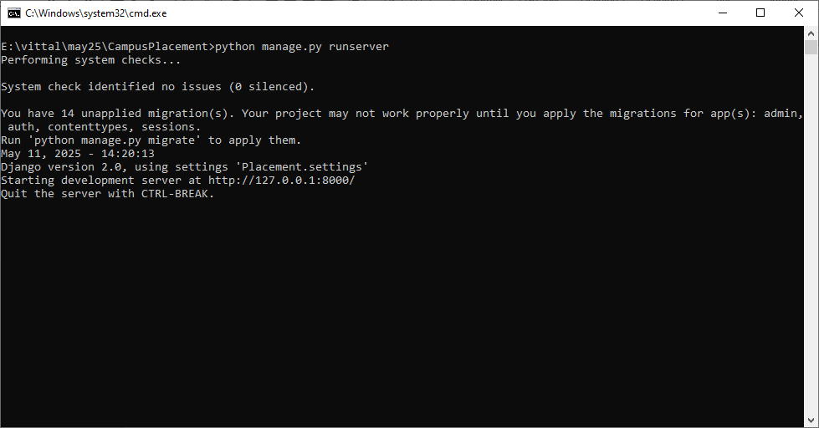

In above screen python server started and now open browser and enter URL as <http://127.0.0.1:8000/index.html> and then press enter key to get below page

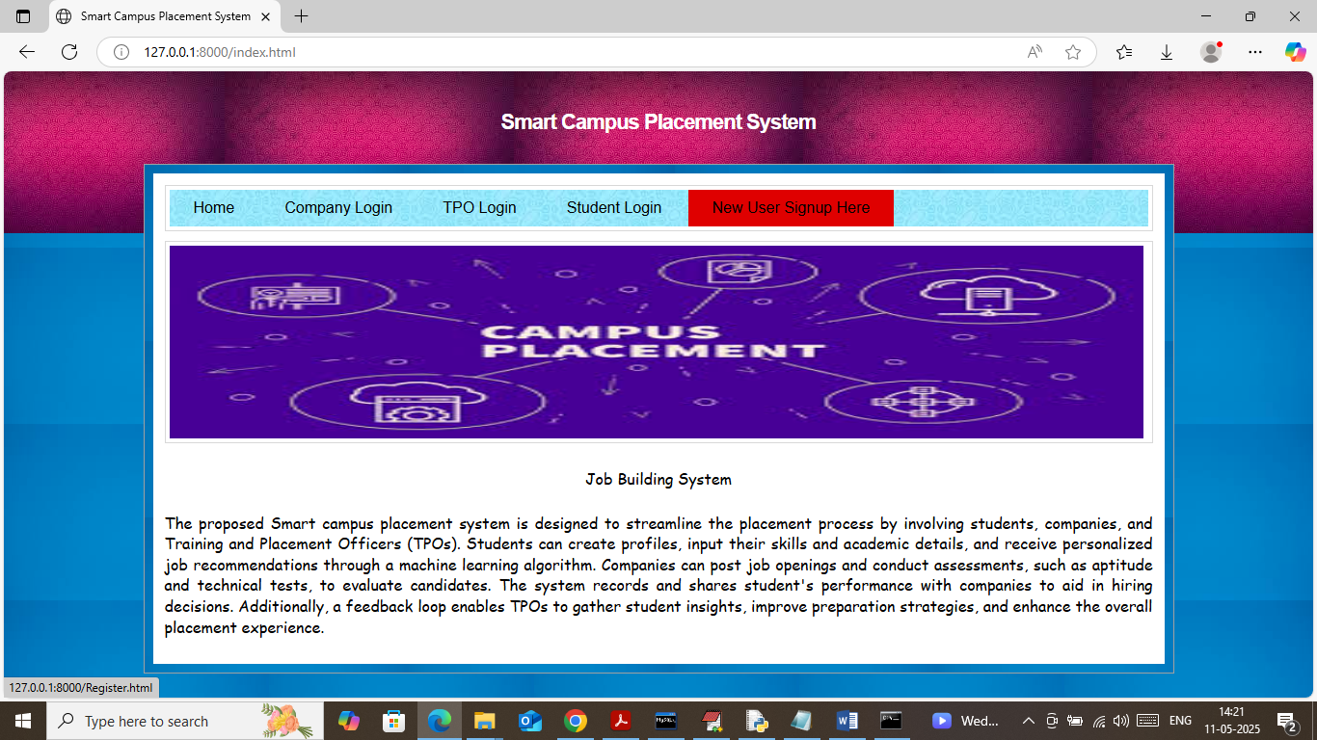

In above screen click on ‘New User Sign up’ link to get below page

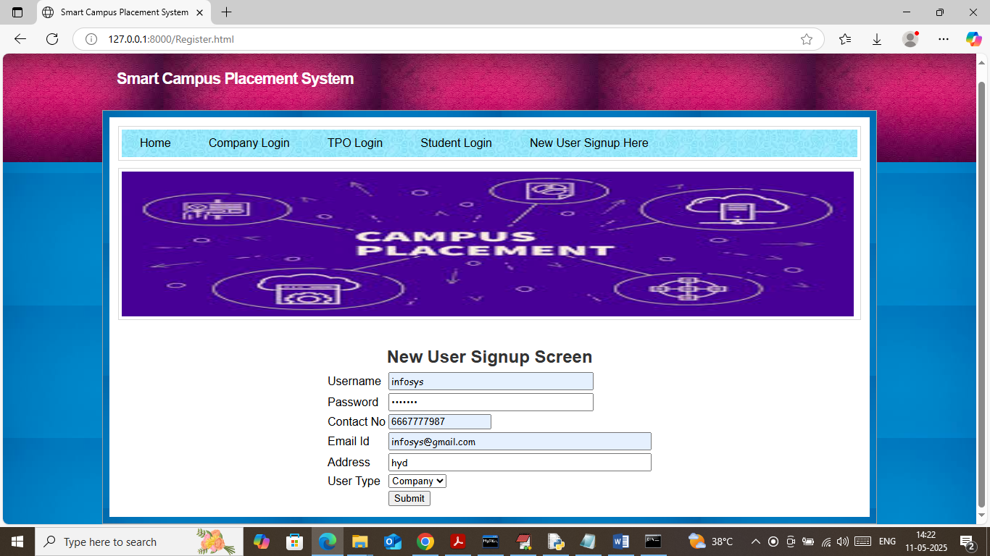

In above screen company is getting registered and then press button to get below page

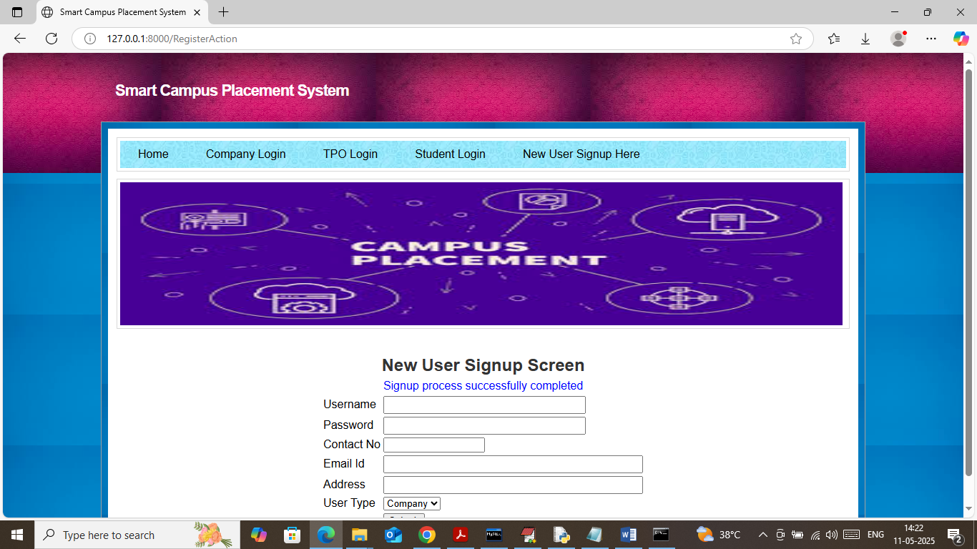

In above screen sign up process completed and now register TPO user

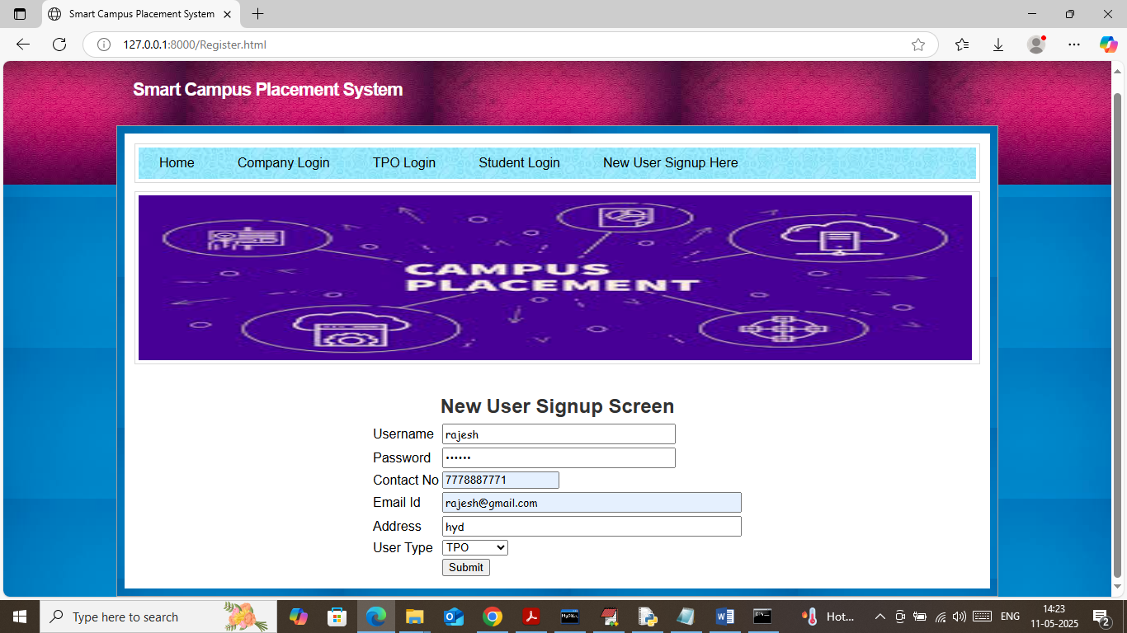

In above screen TPO is getting registered and press button to complete sign up and in below screen student is getting sign up

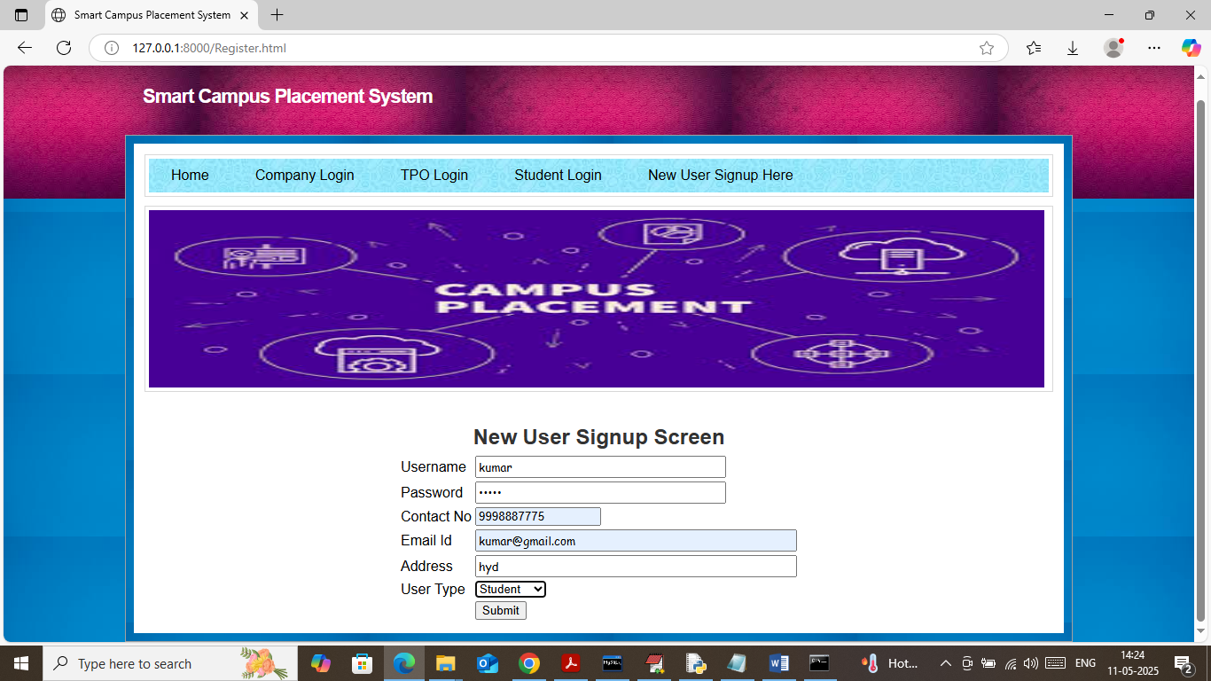

In above screen student is getting sign up and then press button to get below page

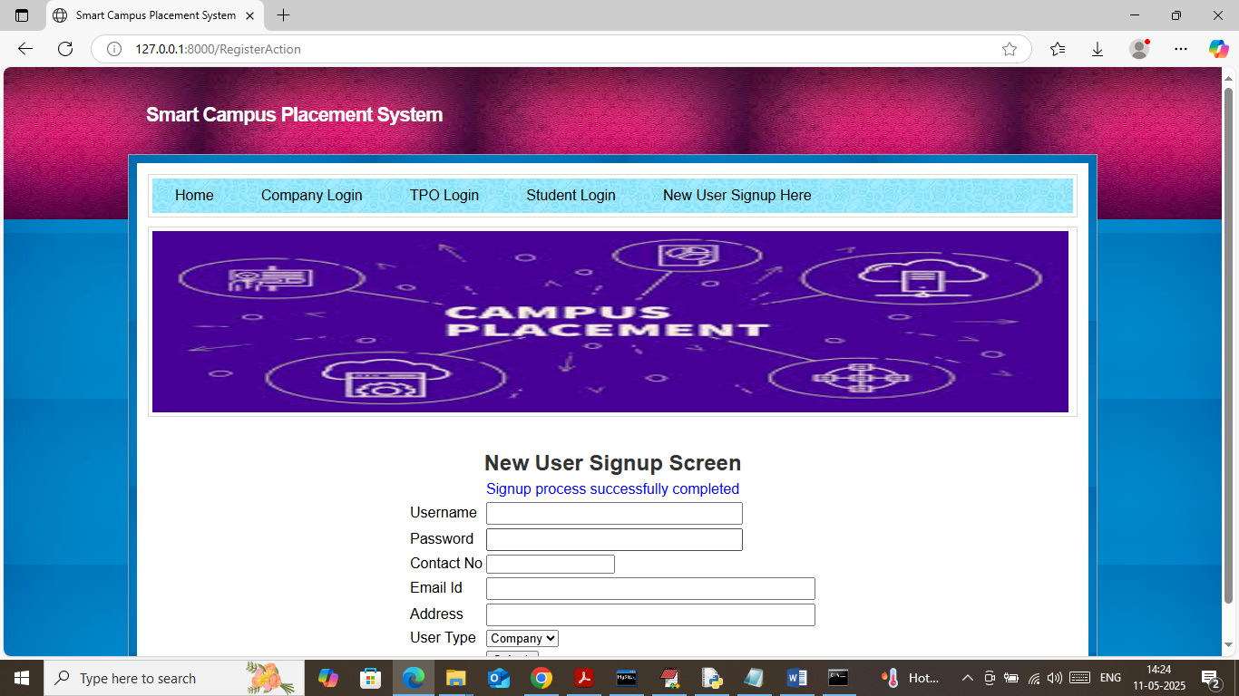

In above screen student sign up completed and now click on ‘Company Login’ link to get below page

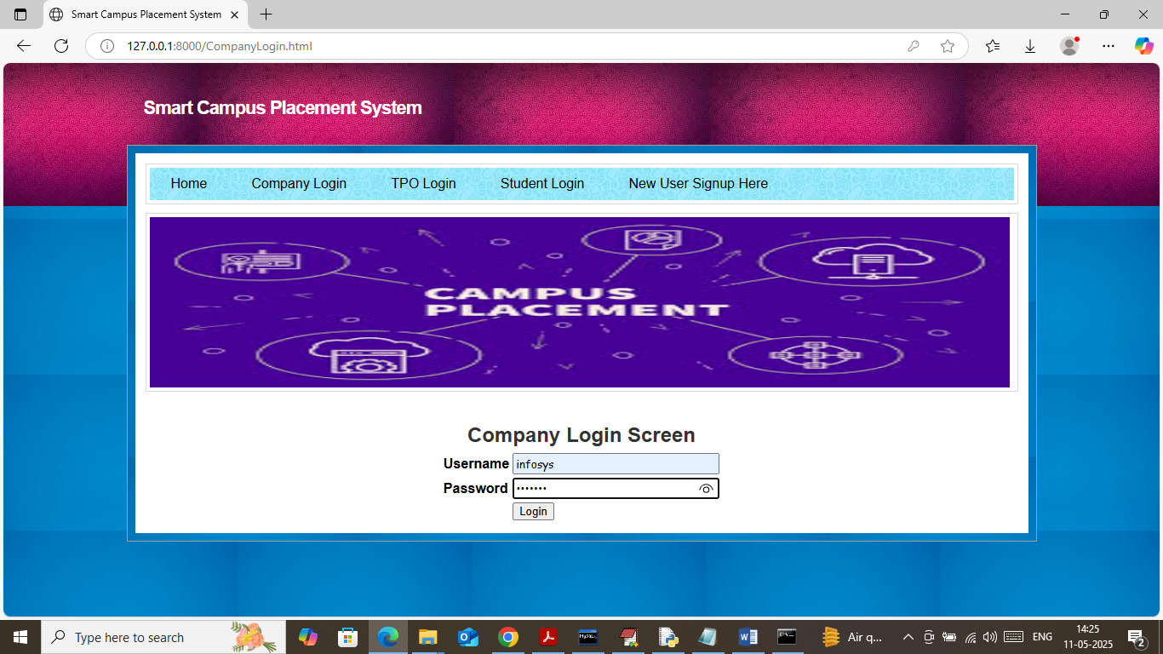

In above screen company is login and after login will get below page

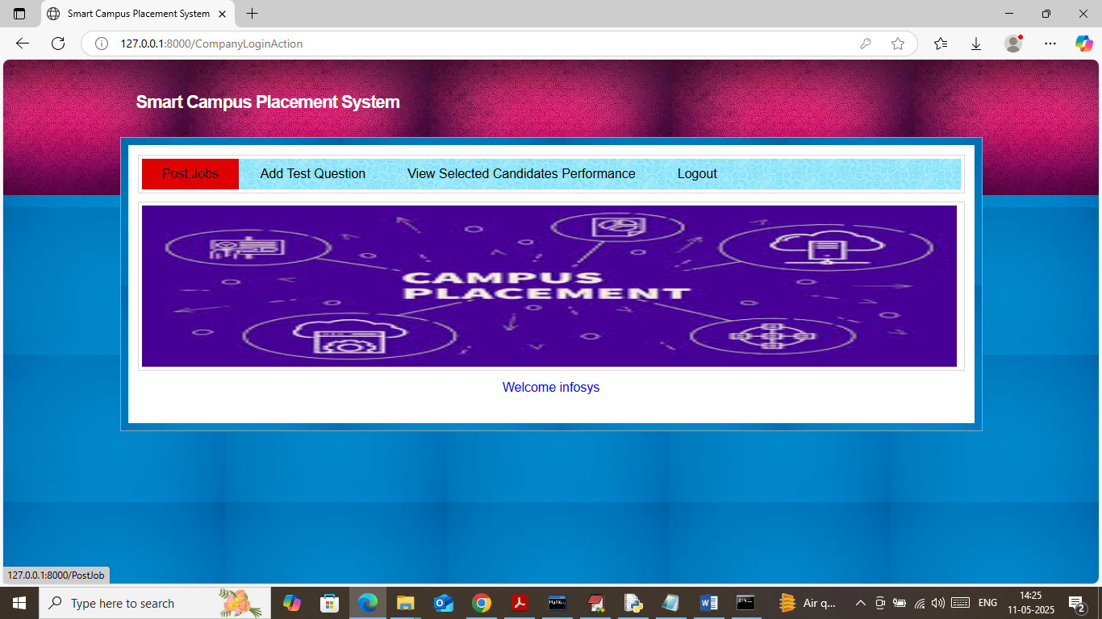

In above screen company can click on ‘Post Job’ link to get below page

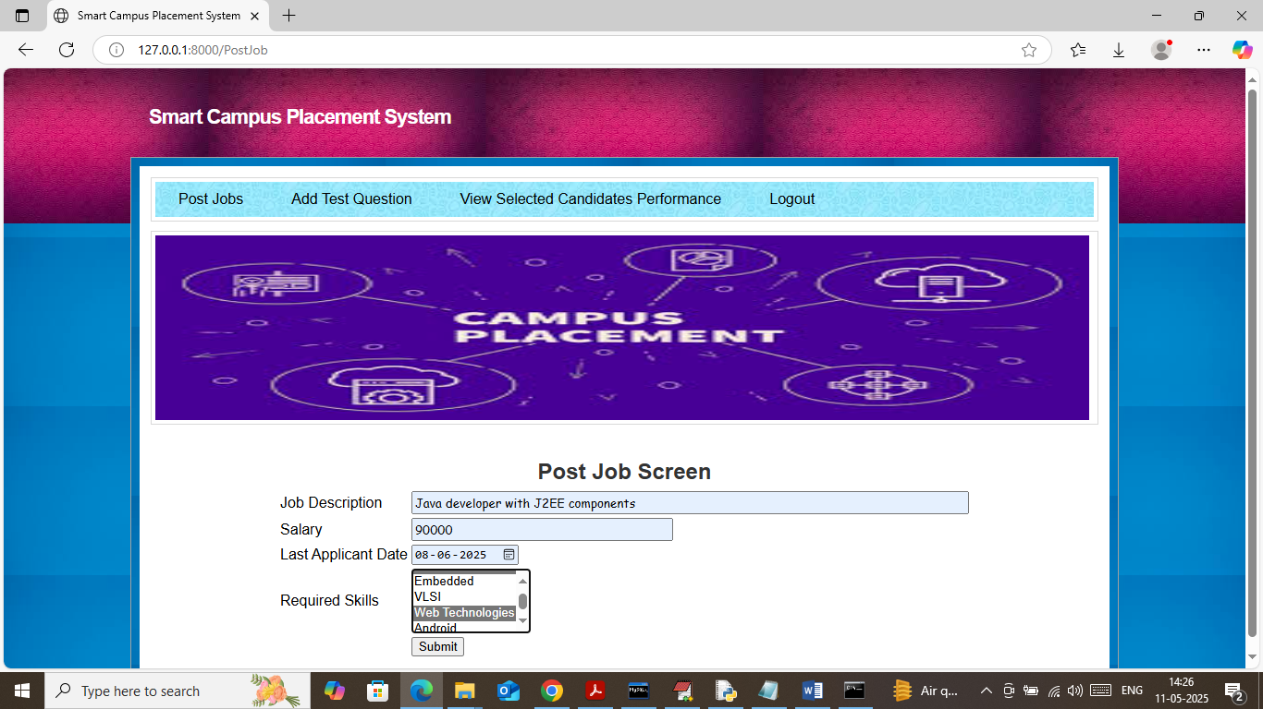

In above screen company can write job description and then select multiple skills by holding CTRL key from keyboard and then press button to get below page

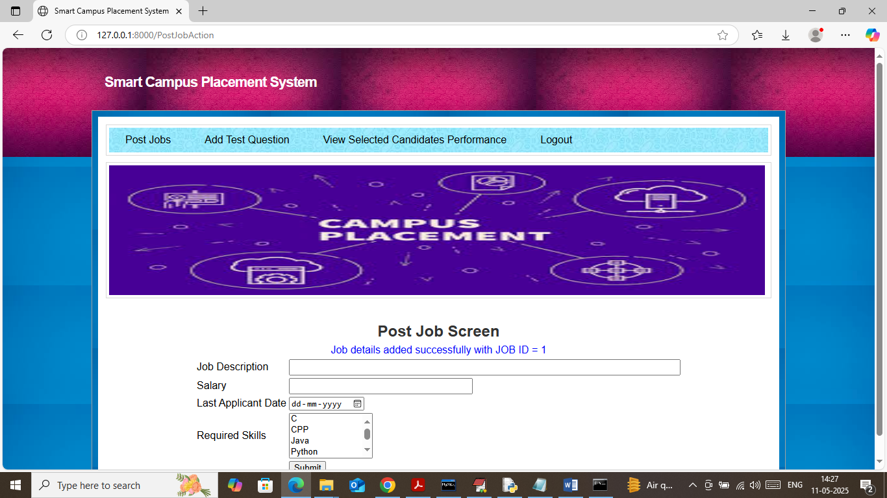

In above screen job details added and similarly you can post as many jobs as you want and now click on ‘Add Test Question’ link to get below page

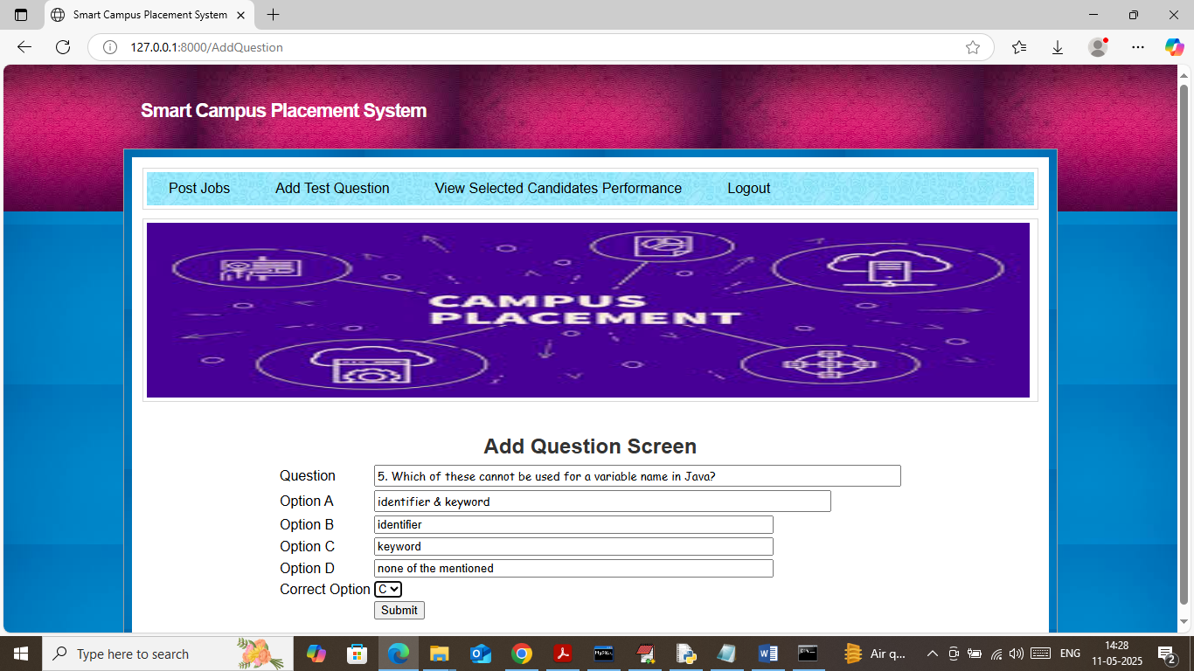

In above screen company can write all test questions along with options and then choose correct answer for evaluation and then press button to get below page

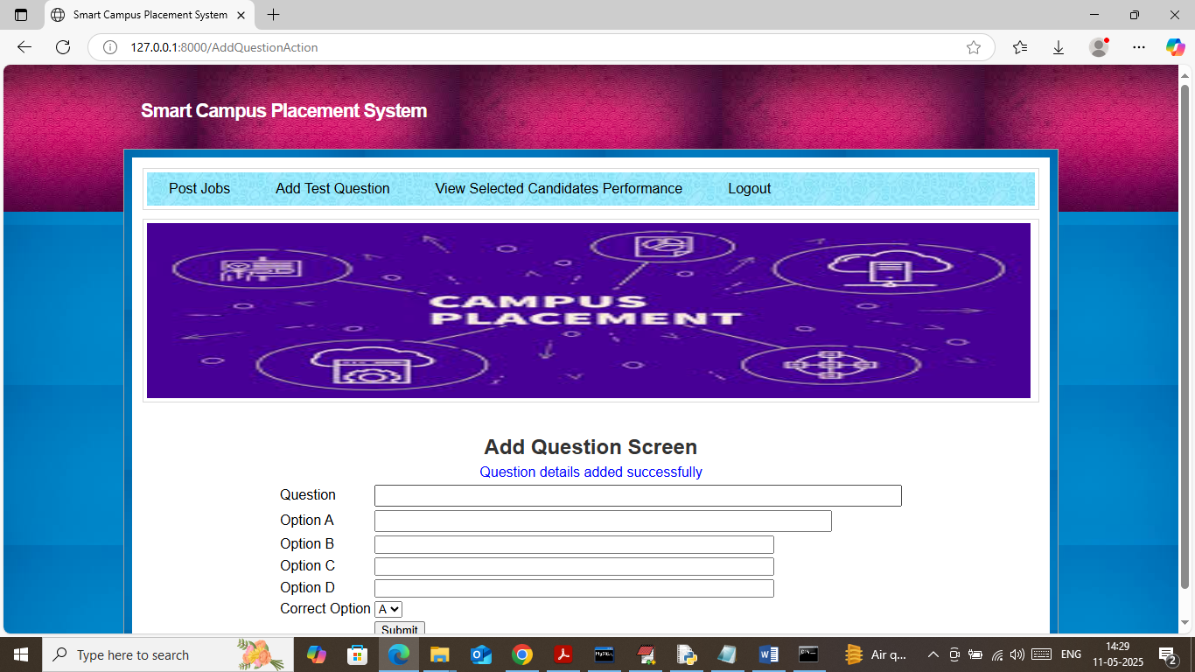

In above screen question details added and similarly you can post as many questions as you want. All the above question details you can find inside ‘questions.txt file’. Now logout and login as student to apply for job

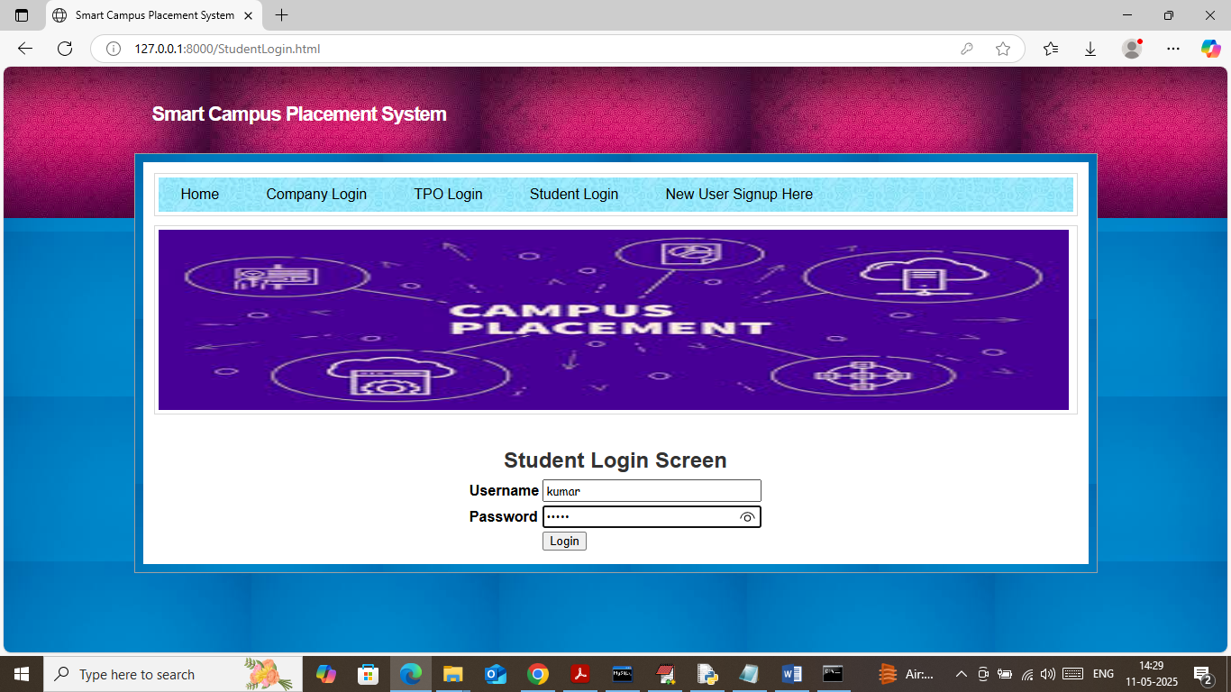

In above screen student is login and after login will get below page

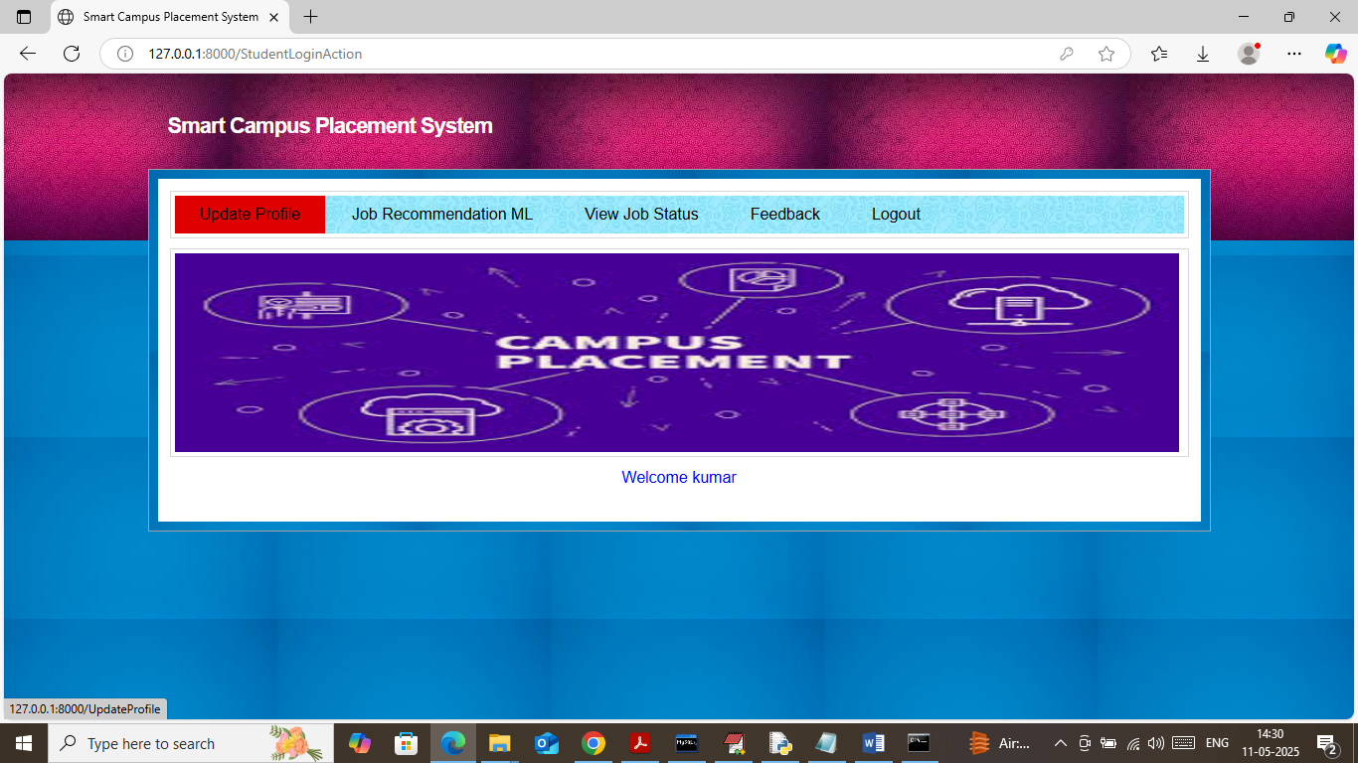

In above screen click on ‘Update Profile’ link to get below page

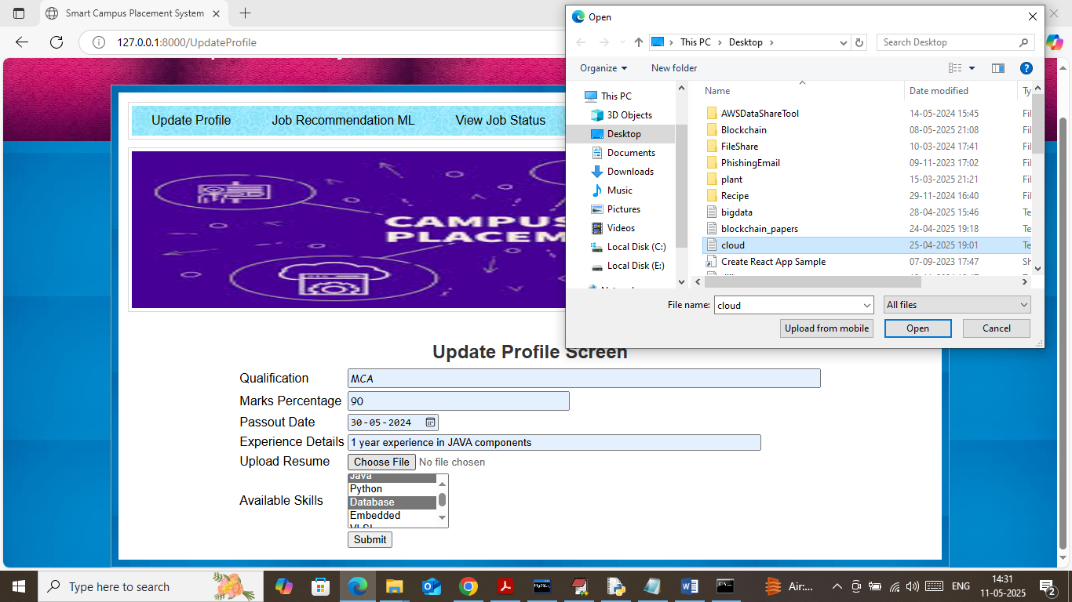

In above screen student can add all academic details along with experience and resume upload and then press button to get below page

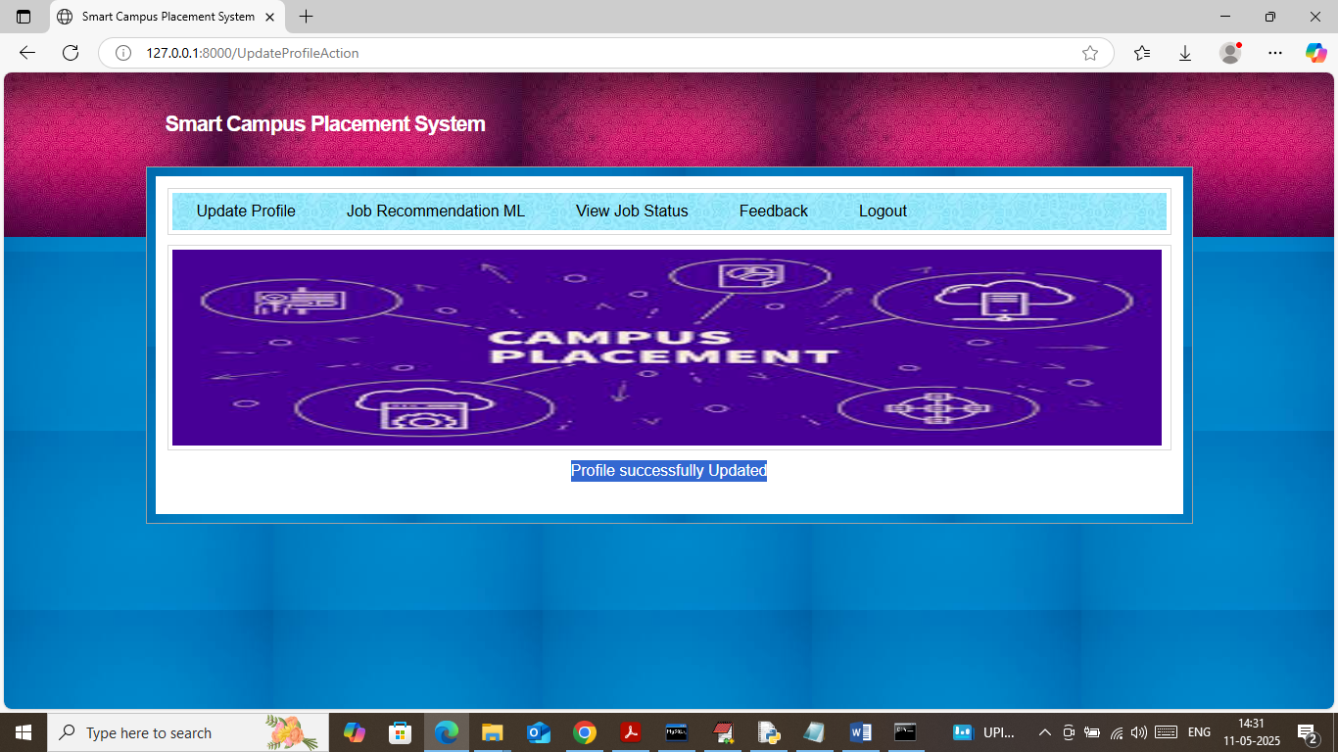

In above screen profile updated successfully and now click on ‘Job Recommendation’ link to get below job list

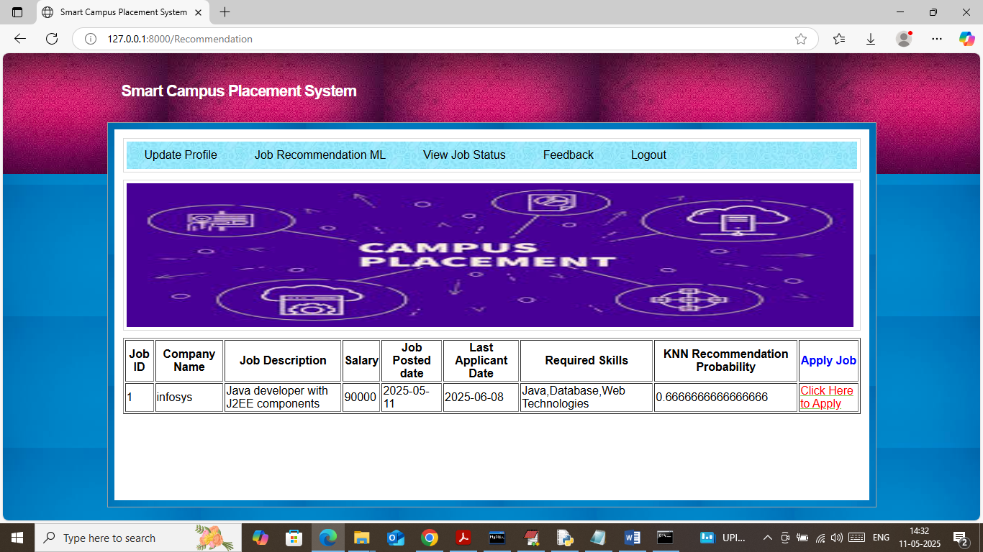

In above screen student can view list of job matching with his skills and KNN found students skills matched with JOB skills up to 66%. Once student applied for job then he will not get same job again in recommendation list. Now click on ‘Click Here to Apply’ link to get below question paper

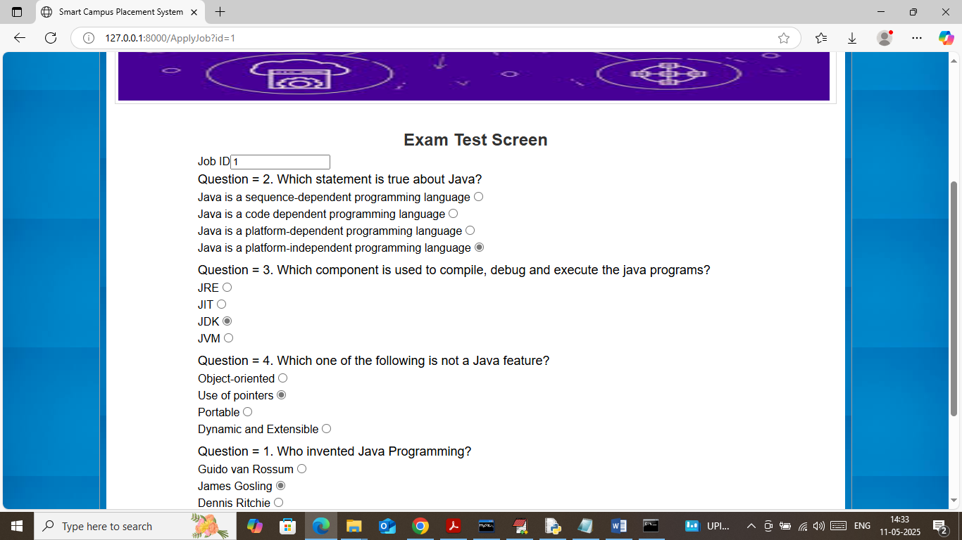

In above screen student has to choose correct option radio button and then press last button to get below scores

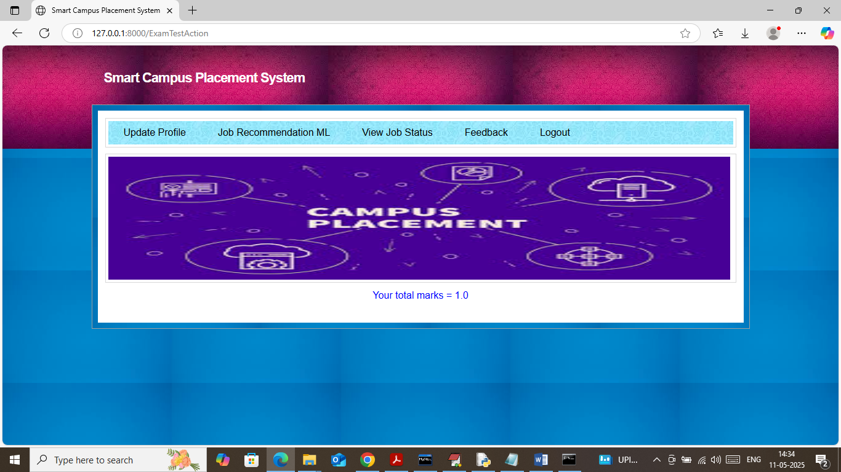

In above screen student scored 100% and now click on ‘View Job Status’ link to get below page

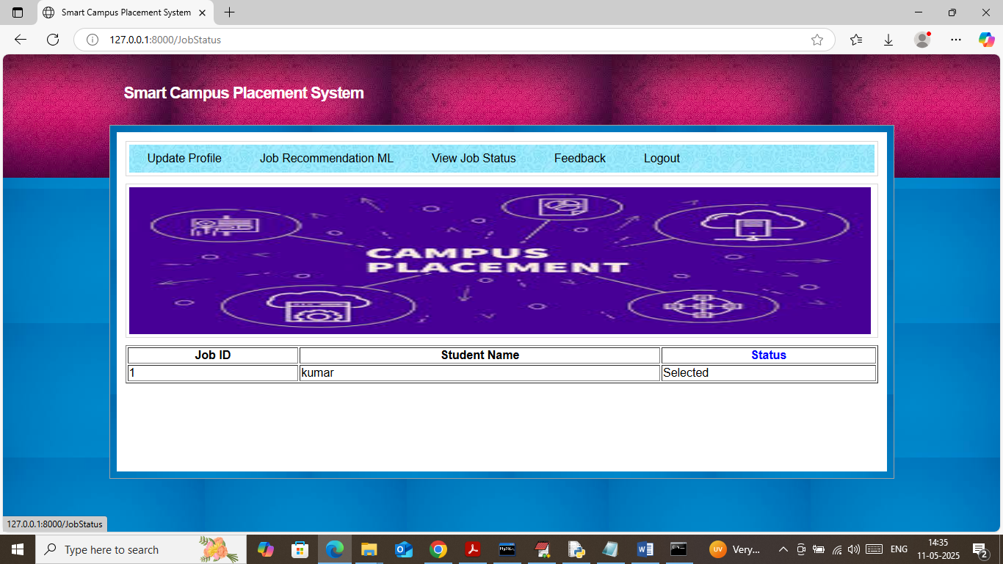

In above screen based on student got selected based on performance score and now click on ‘Feedback’ link to get below page

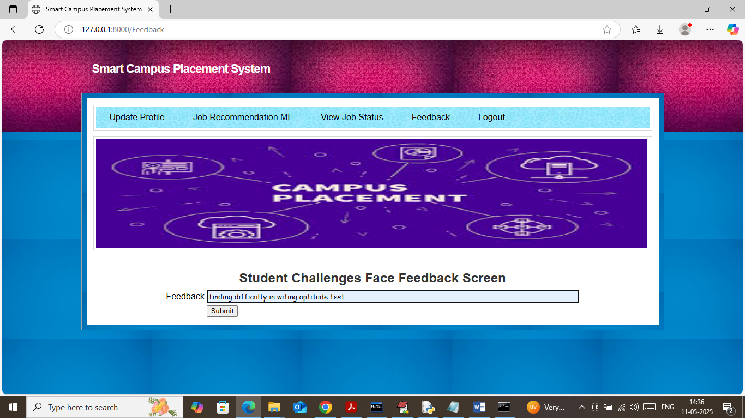

In above screen student can write some feedback and then press button to get below page

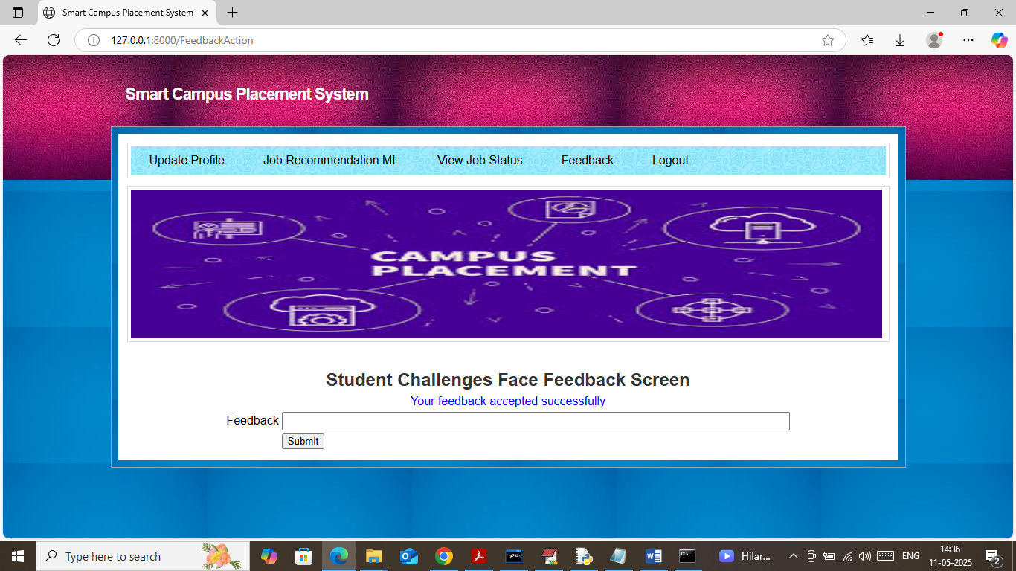

In above screen feedback accepted and now logout and login as TPO to view feedback

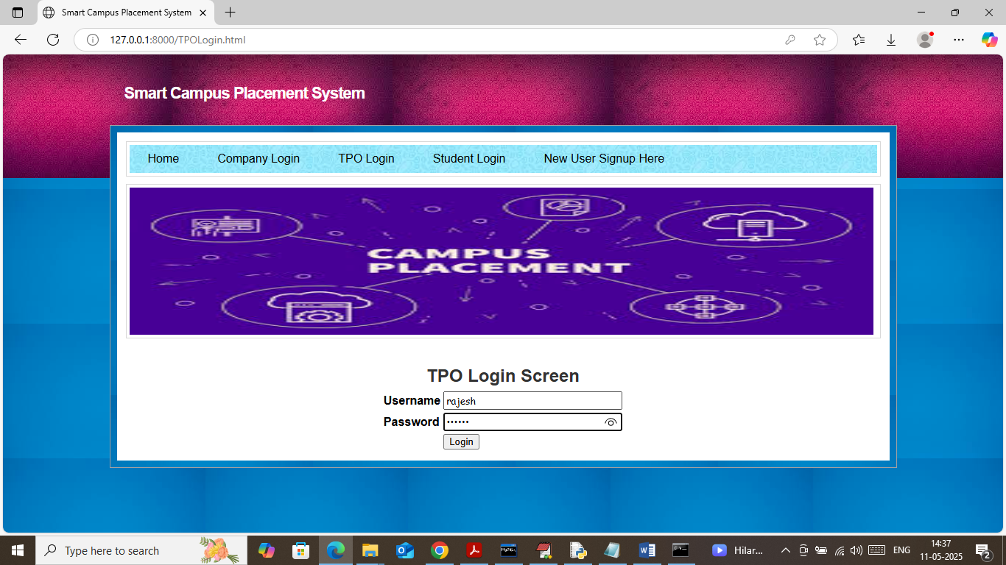

In above screen TPO is login and after login will get below page

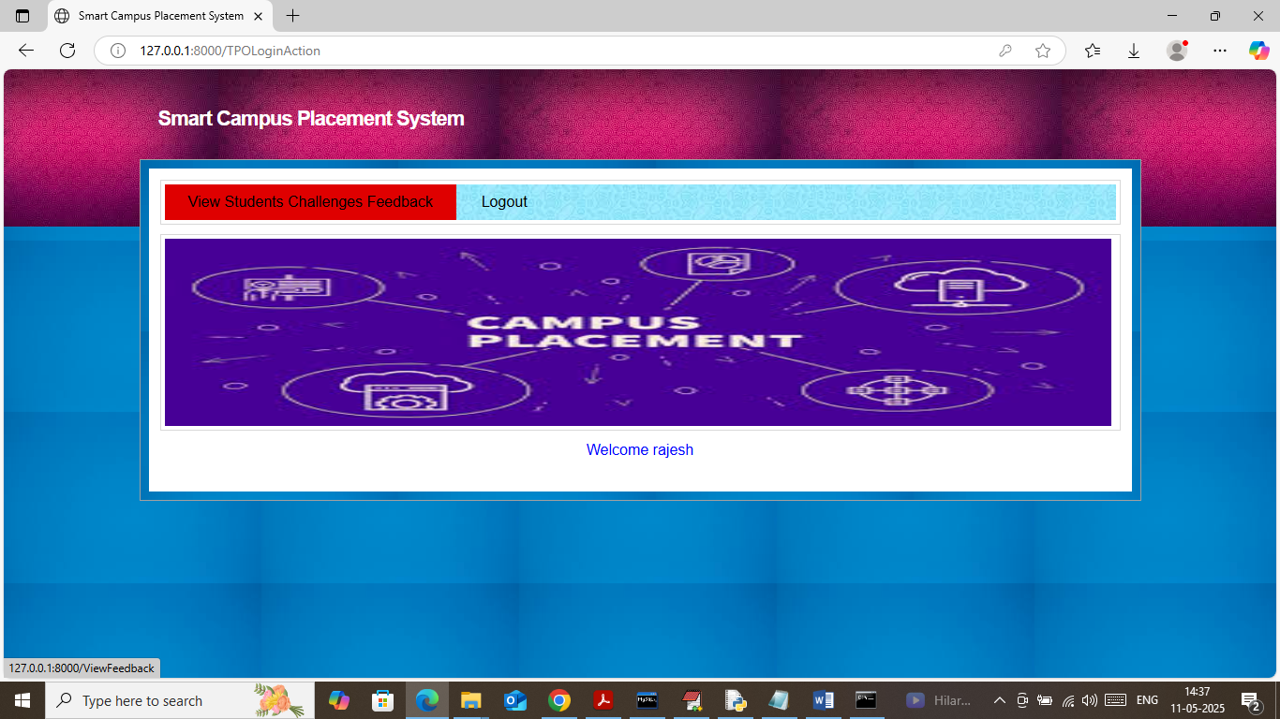

In above screen TPO can click on ‘View Student Feedback Challenges’ link to get below page

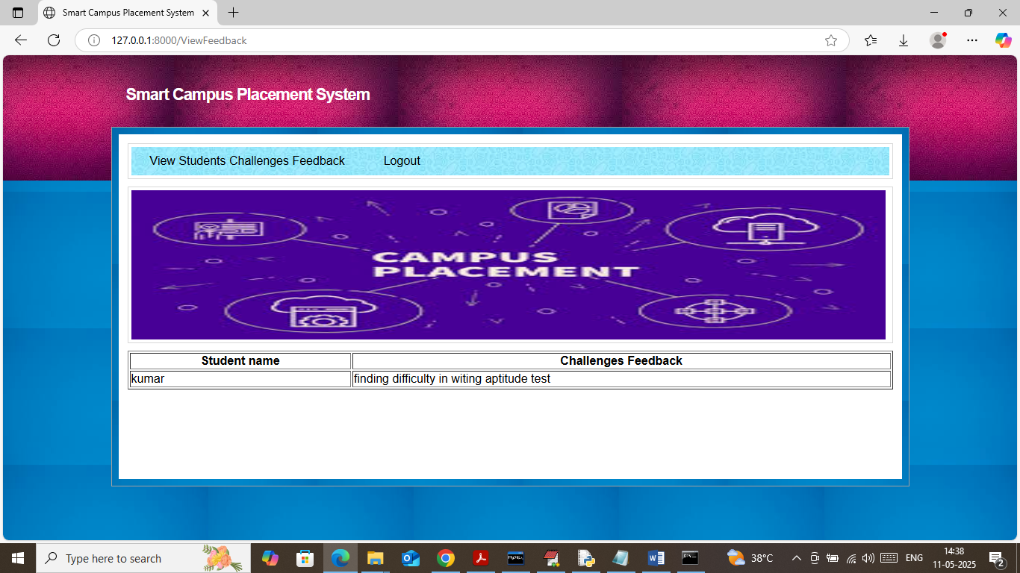

In above screen TPO can see all feedbacks from all students.

So by following above screens you can run completed project with all 3 users modules